AIM: Financial Forecasting
Exercise 7: Financial Forecasting
Scenario:
You are developing a financial forecasting tool that predicts future values based on past data.
Steps:
- Understand Recursive Algorithms:
  - Explain the concept of recursion and how it can simplify certain problems.
- Setup:
  - Create a method to calculate the future value using a recursive approach.
- Implementation:
  - Implement a recursive algorithm to predict future values based on past growth rates.
- Analysis:
  - Discuss the time complexity of your recursive algorithm.
  - Explain how to optimize the recursive solution to avoid excessive computation.

What is Recursion?
Recursion is a programming technique where a method calls itself to solve a problem.
A recursive solution consists of:
- Base Case: Stops the recursion.
- Recursive Case: Calls the same method with a smaller problem.
Example
factorial(5)
= 5 × factorial(4)
= 5 × 4 × factorial(3)
...
= 5 × 4 × 3 × 2 × 1
Recursion simplifies problems that can be divided into smaller subproblems.

FinancialForecast.java
public class FinancialForecast {
public static double predictFutureValue(double currentValue,
double growthRate,
int years) {
// Base Case
if (years == 0) {
return currentValue;
}
// Recursive Case
return predictFutureValue(
currentValue * (1 + growthRate),
growthRate,
years - 1
);
}
public static void main(String[] args) {
double currentValue = 10000.0;
double growthRate = 0.10; // 10%
int years = 5;
double futureValue = predictFutureValue(
currentValue,
growthRate,
years
);
System.out.printf(
"Predicted Future Value after %d years = %.2f%n",
years,
futureValue
);
}
}
Output
Predicted Future Value after 5 years = 16105.10

SCREENSHOTS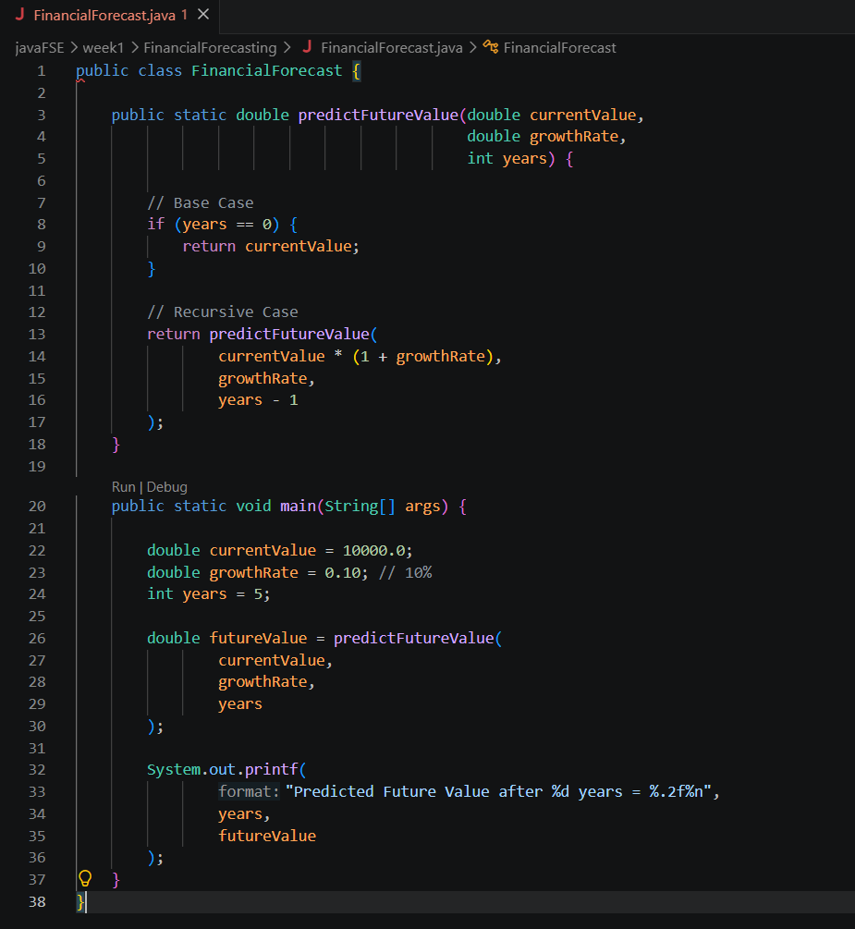
Output:

